CHAPTER NO- 1

LITERATURE REVIEW

1.1 LITERATURE REVIEW
The literature review for the proposed Cloud Integrated Biometric Thumb Attendance System is based on an extensive study of research papers, journals, conference proceedings, and existing attendance management systems. In recent years, there has been a significant increase in the demand for secure, reliable, and automated attendance systems in educational institutions, corporate organizations, and industrial environments. This demand has been driven by the limitations of traditional attendance methods and the need for efficient data management.
Traditional attendance systems primarily rely on manual methods such as paper-based registers, sign-in sheets, or ID card-based entry systems. While these methods are simple and inexpensive, they suffer from several drawbacks. Manual attendance recording is time-consuming, especially in large classrooms or organizations, and is prone to human errors such as incorrect entries, duplication, and data inconsistency. Moreover, these systems allow proxy attendance, where one person can mark attendance on behalf of another, compromising the authenticity of records. Maintaining and storing physical records over long periods is also inefficient, as it requires storage space and makes data retrieval difficult.
To address these issues, researchers introduced automated attendance systems based on technologies such as RFID, barcode scanning, and biometric authentication. Among these, biometric systems have gained significant attention due to their ability to uniquely identify individuals based on physiological or behavioral characteristics. Biometric authentication includes techniques such as fingerprint recognition, iris scanning, facial recognition, and voice recognition. Among these methods, fingerprint recognition is the most widely used due to its reliability, cost-effectiveness, ease of implementation, and high accuracy.
Several studies have demonstrated that fingerprint-based attendance systems provide a secure and efficient solution by eliminating duplicate entries and preventing proxy attendance. These systems capture fingerprint images, extract unique features, and store them as templates in a database. During authentication, the captured fingerprint is compared with stored templates using pattern matching algorithms. The performance of such systems is evaluated based on parameters such as False Acceptance Rate (FAR) and False Rejection Rate (FRR), which indicate the accuracy and reliability of the system.
Early biometric systems, however, were mostly standalone systems that stored data locally. While these systems improved security, they lacked connectivity and scalability. Data stored locally was difficult to access remotely, and managing large datasets across multiple locations was challenging. This limitation led to the integration of biometric systems with network-based and cloud technologies.
With the advancement of cloud computing, modern attendance systems now incorporate cloud platforms for data storage and management. Cloud-based systems provide centralized storage, allowing attendance data to be accessed from anywhere at any time. This enables real-time monitoring, efficient data management, and easy report generation. Cloud integration also enhances scalability, as the system can handle large amounts of data without requiring physical storage infrastructure.
In addition to cloud computing, the integration of Internet of Things (IoT) technology has further improved attendance systems. IoT enables devices such as sensors and microcontrollers to communicate over the internet, allowing real-time data transmission and remote control. Microcontrollers like Arduino, ESP8266, and ESP32 are widely used in IoT-based systems due to their low cost, compact size, and built-in Wi-Fi capabilities. These devices act as the core processing units, connecting biometric sensors with cloud platforms.
Researchers have also explored hybrid systems that combine biometric authentication with additional features such as mobile applications, SMS notifications, and analytics dashboards. These systems provide enhanced functionality, allowing administrators to monitor attendance patterns, generate reports, and make data-driven decisions.
Despite these advancements, several challenges still exist. Biometric systems may face issues related to sensor accuracy, especially when fingerprints are dirty, wet, or damaged. Cloud-based systems depend on stable internet connectivity, and any network failure can disrupt data transmission. Data security and privacy are also major concerns, as sensitive biometric data must be protected from unauthorized access.
Therefore, there is a need for a system that effectively combines biometric authentication with cloud integration while addressing these challenges. The proposed Cloud Integrated Biometric Thumb Attendance System aims to provide a secure, efficient, and user-friendly solution by leveraging fingerprint recognition, embedded systems, and cloud technology. This system ensures accurate attendance recording, prevents fraud, and enables real-time data access, making it suitable for modern applications.

1.2 Literature Survey
Over the past decade, numerous attendance management systems have been developed using a variety of technologies, each offering different levels of efficiency, security, and complexity. These systems include RFID-based systems, barcode-based systems, biometric authentication systems, and IoT-based smart attendance systems. A detailed survey of these technologies provides insights into their advantages, limitations, and areas for improvement.

RFID-based attendance systems were among the earliest automated solutions and gained popularity due to their simplicity and low cost. In these systems, users are provided with RFID cards that are scanned to mark attendance. While these systems reduce manual effort and speed up the attendance process, they suffer from significant security issues. RFID cards can be easily exchanged among users, allowing proxy attendance. Additionally, these systems require additional hardware and maintenance, which increases operational costs.

Barcode-based systems operate on a similar principle, where each user is assigned a unique barcode that is scanned for attendance. Although these systems are easy to implement, they are not secure, as barcodes can be duplicated or misused. Furthermore, barcode scanners require proper alignment and maintenance, which can affect system performance.

Biometric attendance systems, particularly those based on fingerprint recognition, have emerged as a more secure alternative. These systems use unique biological characteristics to identify individuals, ensuring that attendance can only be marked by the authorized person. Research studies have shown that biometric systems significantly reduce fraud and improve accuracy. However, these systems may face challenges such as sensor errors due to environmental conditions and higher initial setup costs.

Recent advancements have led to the integration of biometric systems with IoT and cloud technologies. IoT-based attendance systems use microcontrollers and wireless communication to transmit data in real time. These systems enable remote monitoring and centralized data management, making them suitable for large organizations. Cloud-based systems further enhance functionality by providing scalable storage, real-time access, and data analytics capabilities.

Several studies have proposed smart attendance systems that integrate biometric authentication with cloud platforms. These systems allow administrators to access attendance records remotely, generate reports, and monitor attendance trends. Some advanced systems also include features such as mobile applications, SMS/email notifications, and graphical dashboards for data visualization.

Despite these improvements, existing systems still have certain limitations. Many systems are complex and expensive to implement, especially in large-scale environments. Some systems lack real-time synchronization, leading to delays in data updates. Data security and privacy remain critical concerns, as biometric data must be protected from unauthorized access. Additionally, most cloud-based systems depend on continuous internet connectivity, which may not always be reliable.

Another limitation is the lack of integration between different technologies. Some systems focus only on biometric authentication without cloud support, while others provide cloud storage but lack secure authentication mechanisms. This creates a gap in developing a fully integrated system that combines security, efficiency, and accessibility.

To overcome these limitations, the proposed system integrates multiple technologies into a single solution. It uses fingerprint-based biometric authentication for secure user identification, ensuring that only authorized individuals can mark attendance. A microcontroller-based system processes the data and communicates with a cloud platform using Wi-Fi, enabling real-time data storage and remote access. An OLED display is used to provide immediate feedback to users, improving system usability.

This integrated approach ensures a balance between cost, performance, and security. The system is designed to be scalable, allowing it to be deployed in various environments such as schools, colleges, offices, and industries. It can also be extended in the future by adding features such as mobile applications, advanced analytics, and AI-based decision-making systems.

In conclusion, the literature survey highlights the evolution of attendance systems from manual methods to advanced IoT-based biometric systems. While each technology has its advantages, the combination of biometric authentication and cloud integration provides the most effective solution. The proposed system builds upon these advancements to deliver a secure, efficient, and modern attendance management system.

CHAPTER NO- 2 INTRODUCTION

2.2 MOTIVATION
The motivation behind the development of the Cloud Integrated Biometric Thumb Attendance System originates from the growing need for an efficient, secure, and automated attendance management system in educational institutions and organizations. In many schools, colleges, and workplaces, attendance is still recorded manually using registers or sheets. This traditional approach is not only time-consuming but also highly prone to errors such as incorrect entries, duplication, and most importantly, proxy attendance. Proxy attendance reduces the reliability and authenticity of records, which can negatively impact performance evaluation and discipline.
In addition to this, maintaining physical attendance records over long periods becomes difficult, as they require storage space and are prone to damage or loss. Retrieving past records is also a tedious process. Many institutions face challenges in managing large volumes of attendance data efficiently. Furthermore, manual systems do not provide real-time monitoring, making it difficult for administrators to track attendance instantly.
With the rapid advancement of technology, especially in the fields of biometrics and the Internet of Things (IoT), it has become possible to develop smart systems that can overcome these limitations. Biometric authentication, particularly fingerprint recognition, provides a highly secure method of identifying individuals since fingerprints are unique for every person. This ensures that attendance can only be marked by the actual user, eliminating the possibility of fraud.
Moreover, cloud computing plays a crucial role in modern data management. By integrating attendance systems with cloud platforms, data can be stored securely and accessed from anywhere at any time. This enables real-time monitoring, easy report generation, and better data management. Administrators can analyze attendance patterns and make informed decisions.
The combination of biometric authentication and cloud integration creates a powerful solution that addresses the drawbacks of traditional systems. This project is motivated by the need to design a system that is not only accurate and secure but also efficient, scalable, and user-friendly. It aims to reduce manual effort, improve transparency, and provide a modern approach to attendance management suitable for today’s digital environment.

2.3 OBJECTIVE
The primary objective of this project is to design and implement a Cloud Integrated Biometric Thumb Attendance System that ensures secure, accurate, and efficient attendance management. The system aims to replace traditional attendance methods with a modern, automated solution that utilizes biometric authentication and cloud technology.
One of the key objectives is to develop a fingerprint-based authentication system that uniquely identifies each user. Since fingerprints are unique for every individual, this method ensures high security and eliminates the possibility of proxy attendance. The system captures and verifies fingerprints accurately, ensuring that only authorized users can mark their attendance.
Another important objective is to automate the entire attendance recording process. Manual systems require significant time and effort, especially in large classrooms or workplaces. By automating this process, the system reduces human intervention, minimizes errors, and saves valuable time. The attendance is recorded instantly when a valid fingerprint is detected.
The project also aims to integrate the system with cloud technology. This allows attendance data to be stored in a centralized database that can be accessed remotely. Real-time data storage enables administrators to monitor attendance instantly and generate reports easily. This improves transparency and simplifies data management.
Additionally, the system is designed to provide immediate feedback to users through an OLED display. When a fingerprint is successfully verified, the system displays the user’s name and attendance status. This enhances user interaction and ensures clarity in the system’s operation.
Another objective is to ensure that the system is cost-effective, reliable, and easy to implement. By using components such as ESP32 and fingerprint sensors, the system remains affordable while maintaining high performance. The design is kept simple so that it can be easily deployed in various environments.
Finally, the project aims to develop a scalable system that can be extended in the future. Features such as mobile application integration, SMS or email notifications, and advanced analytics can be added to enhance functionality. The system is designed to meet current needs while also allowing future improvements.
Overall, the objective of this project is to create a smart, secure, and efficient attendance system that overcomes the limitations of traditional methods and provides a modern solution for attendance management.

CHAPTER NO- 3 DATA FLOW DIAGRAM

  - DATA FLOW DIAGRAM
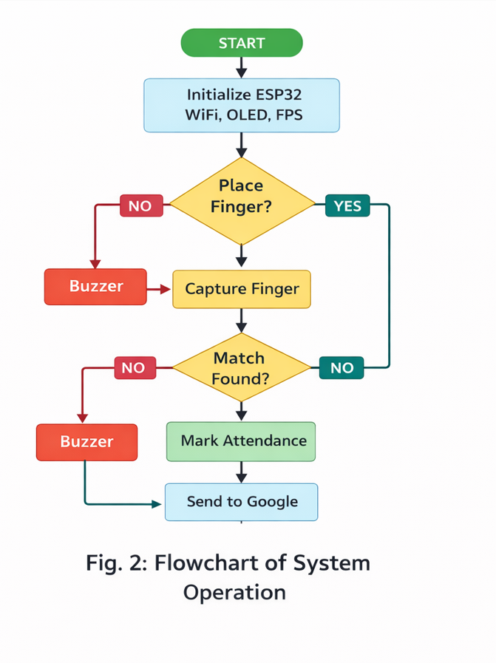
Fig.1.Flow Chart Biometric Attendance Syatem

  - Explanation of System Flow
The flowchart (Fig. Flowchart of System Operation) represents the step-by-step working of the Cloud Integrated Biometric Thumb Attendance System.
Step 1: Start
The system begins its operation when power is supplied to the device.

Step 2: Initialization
The ESP32 microcontroller initializes all connected components:
- WiFi module (for cloud communication)
- OLED display (for output)
- Fingerprint sensor (FPS)
This ensures that all modules are ready for operation.

Step 3: Finger Placement Check
The system continuously checks whether a user has placed their finger on the fingerprint sensor.
- If NO:
  - The system activates the buzzer to indicate waiting or no input
  - It keeps checking again
- If YES:
  - The system proceeds to capture the fingerprint

Step 4: Capture Fingerprint
Once the finger is placed, the fingerprint sensor scans and captures the fingerprint image and converts it into a digital template.

Step 5: Matching Process
The captured fingerprint is compared with the stored fingerprint database.
- If Match NOT Found:
  - The buzzer is activated to indicate invalid user
  - The system returns to waiting state
- If Match Found:
  - The user is successfully authenticated

Step 6: Attendance Marking
After successful authentication, the system marks the attendance of the user along with date and time.

Step 7: Data Transmission to Cloud
The attendance data is sent to the cloud (Google Sheets / Firebase) using WiFi.
This allows:
- Real-time data storage
- Remote monitoring
- Easy report generation

Step 8: Continuous Loop
After completing one cycle, the system returns to the initial state and waits for the next user.

CHAPTER NO- 4 PERFORMANCE ANALYSIS

4.1 PERFORMANCE ANALYSIS / OUTPUT
4.1.1 Internal structure
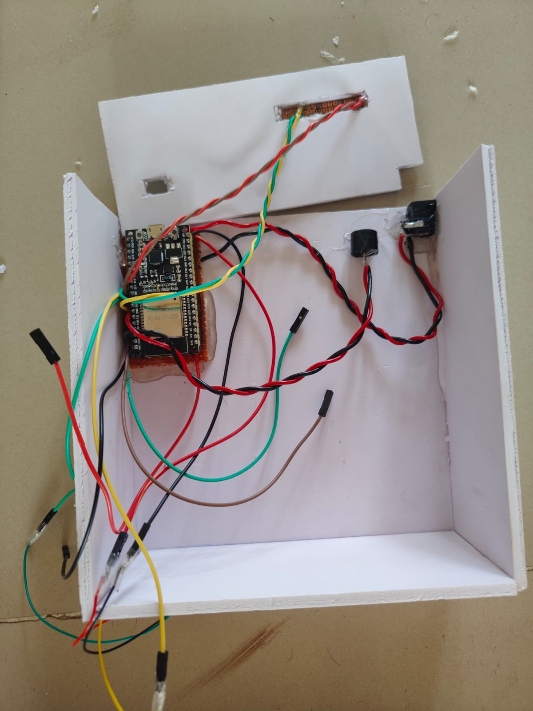
Fig.2.Internal structure
- The internal structure of the system shows the ESP32 microcontroller connected to various components such as the fingerprint sensor, OLED display, and buzzer using jumper wires. All components are mounted inside a compact enclosure, ensuring proper wiring and secure placement. The connections enable data communication, processing, and output display for the attendance system.

4.1.2 Fingerprint Detection
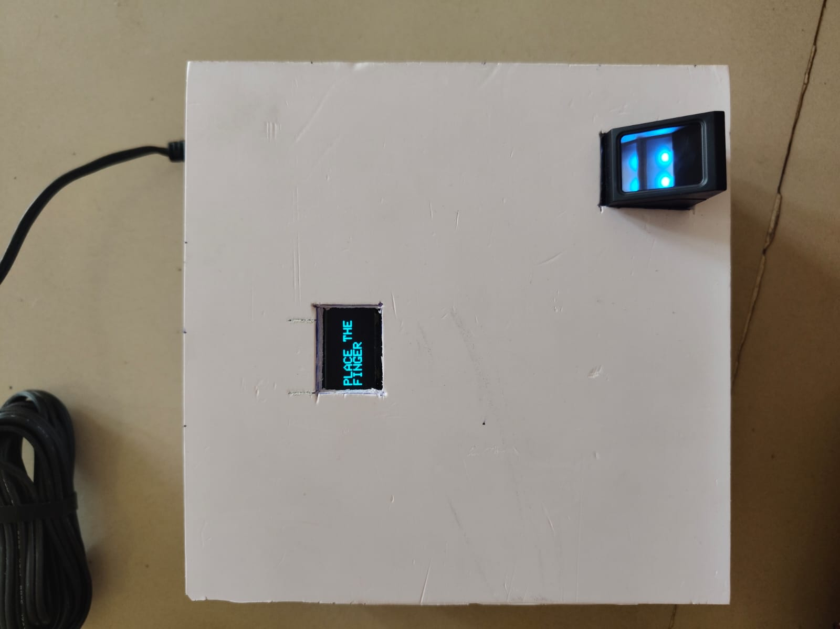
Fig.3.Fingerprint Detection
- The fingerprint sensor successfully detects user fingerprints with high accuracy. It captures unique patterns and converts them into digital data for processing.
- The system compares the captured fingerprint with stored templates. If a match is found, the user is authenticated. The matching process is fast and efficient.

4.1.3 Attendance Recording
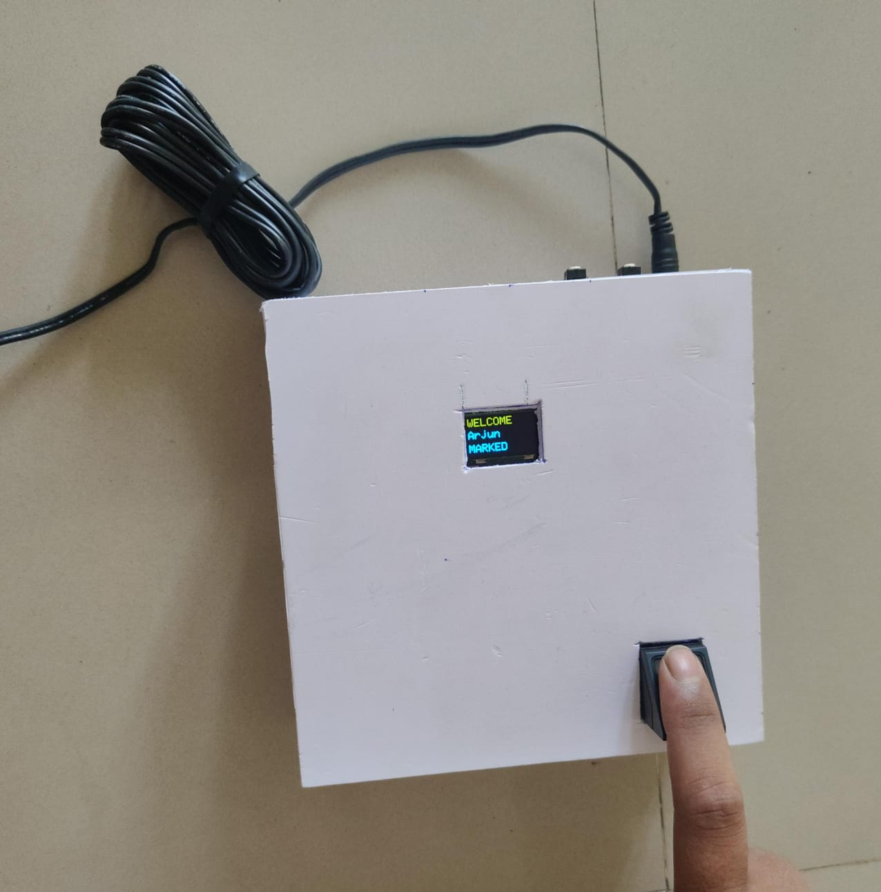
Fig.4.Attendance Recording
- Once authentication is successful, attendance is marked automatically. The system records the date and time of entry.
- The OLED display shows:
- User name
- Attendance status (Marked/Already Present)
- This provides immediate feedback to the user.

4.1.4 Cloud Integration
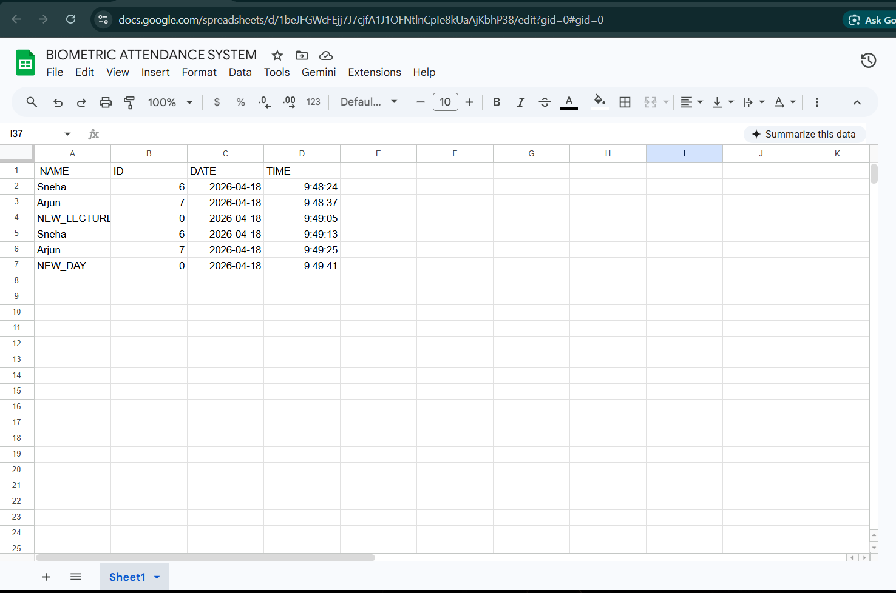
Fig.5.Google sheet responce

- Attendance data is successfully uploaded to the cloud platform. This allows administrators to access records remotely and generate reports.

CHAPTER NO- 5 PROJECT REQUIRMENTS

5.1 SOFTWARE REQUIREMENTS
- Arduino IDE: Used for writing and uploading code
- Embedded C: Programming language for microcontroller
- Cloud Platform: Google Sheet for data storage
- Serial Monitor: Used for debugging and testing
- Libraries: Fingerprint sensor library, OLED display library

5.2 HARDWARE REQUIREMENTS
- Microcontroller (ESP32): Controls system operations
- Fingerprint Sensor: Captures and verifies fingerprints
- OLED Display (0.96 inch): Displays output information
- Power Supply (5V Adapter): Provides stable voltage
- Buzzer: Gives audio feedback
- Wires & PCB: For circuit connections

CHAPTER NO- 6 PROJECT ADVANTAGES AND DISSADNATAGES

6.1 Advantages of Cloud Integrated Biometric Attendance System:
●Ellimination of proxy attendence
Biometric authentication ensures that only the authorized person can mark attendance. Since fingerprints are unique, it completely removes the possibility of fake or proxy attendance.

●High accuracy and security
The system uses fingerprint recognition technology which provides a high level of accuracy and security compared to traditional methods like manual registers or RFID cards.

●Automated and time efficient system
The system automatically records attendance without manual intervention. This saves time during lectures or working hours and improves overall efficiency.

●Cloud-Based data management
Attendance data is stored on the cloud, allowing users to access it anytime and from anywhere. It also reduces the need for physical storage.

●Real-Time monitoring
Administrators can monitor attendance in real-time, which helps in better tracking and management of records.

●Reduced paperwork
The system eliminates the need for maintaining physical registers, thereby reducing paperwork and making the system eco-friendly.

6.2 Disadvantages of Cloud Integrated Biometric Attendance System:
●Initial setup cost
The cost of biometric devices, microcontrollers, and cloud setup may be high during the initial implementation.

●Dependency on internate connectivity
Since the system uses cloud storage, it requires a stable internet connection. Any network failure can interrupt data uploading.

●Fingerprint recognization issues
The system may face difficulty in recognizing fingerprints if the finger is dirty, wet, or damaged.

●Data security concern
As data is stored on the cloud, there is a risk of data breaches if proper security measures are not implemented.

●Hardware dependency
The system relies on hardware components like sensors and microcontrollers. Any hardware failure can affect system performance.

CHAPTER NO- 7 CONCLUSION

7.1 CONCLUSION

The suggested attendance system with biometrics integrated with cloud services will be effective and reliable for attendance purposes. Through the use of fingerprint and IoT, the proposed attendance system will ensure accuracy, efficiency, and real-time data storage.
The inclusion of ESP32 makes it possible for wireless communication. Also, with Google Sheets, it becomes possible to have an easily accessible attendance record.
Moreover, the proposed attendance system is efficient in terms of cost, scalability, and applicability.
The developed cloud-integrated attendance system with biometric thumb recognition in this project is an efficient, reliable, and accurate method for attendance purposes. With the use of fingerprints in attendance, there will be no proxy attendance cases and other forms of errors that might arise when using manual methods.
With the incorporation of ESP32 microcontroller with WiFi, it will be possible to transmit attendance records in real-time and hence access the attendance record from any place through Google Sheets. Furthermore, the OLED display facilitates user interaction and gives status information on the system.
Other additional functionalities include the use of reset buttons for reset on daily basis and per lecture basis, which makes the whole system flexible and appropriate for application in the real world scenarios. This system has been developed in a cost-effective and user-friendly manner that can accommodate more users.
In conclusion, the project has proved very successful in illustrating how the technology of biometric authentication and IoT can be effectively applied in automation of attendance systems.

REFERENCES
- Ezeofor Chukwunazo Joseph and Georgewill Onengiye Moses (2019) developed an IoT-based student attendance monitoring system using fingerprint sensors and ESP32. The system provided accurate attendance and cloud storage but was limited by network dependency and system complexity.
- Kotramma T. S., AzizKhan F. Pathan, Vinayaka G., Varshitha A. M., and Vikram K. Yashaswini (2023) proposed an automatic attendance system using machine learning and facial recognition techniques. The system improved automation and accuracy but required high computational power and proper lighting conditions.
- Jawaaz Ahmad and Zahid Gulzar Khaki (2016) presented a smart classroom attendance system using sensor-based technologies such as NFC and RFID. The system improved efficiency but lacked strong authentication, allowing possible proxy attendance.
- Sudip Misra, Anandarup Mukherjee, and Arijit Roy (2021) explained the fundamentals of IoT and its applications in real-time data communication and cloud integration. However, IoT systems depend on reliable network connectivity and security mechanisms.
- A. K. Jain, A. Ross, and S. Prabhakar (2004) presented an overview of biometric recognition systems, highlighting fingerprint authentication as a highly secure and reliable method. However, performance may vary based on environmental conditions.
- Roy Want (2018) discussed the concept of the Internet of Things and its applications in data communication and cloud-based systems. While effective, such systems require stable internet connectivity.
- S. Prabhakar and A. K. Jain (2017) explored biometric authentication techniques and their applications in embedded systems. The system was reliable but lacked integration with real-time cloud communication.
- Espressif Systems (2021) demonstrated the use of ESP32 microcontroller for IoT-based wireless communication systems. The system was efficient but dependent on network availability and configuration.
- S. Gupta and P. Verma (2020) proposed an automated attendance system using fingerprint verification. The system reduced manual effort and improved accuracy but required proper user enrollment and maintenance.
- A. Sharma and R. Patel (2019) developed a smart attendance system integrating biometric authentication with IoT technologies. The system improved efficiency but increased system complexity and maintenance requirements.

